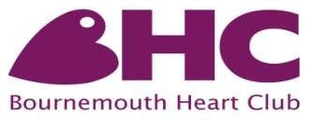

Dear Dr
Approval for Patient to return to Phase 4 Cardiac Rehabilitation Sessions
The Bournemouth Heart Club (BHC) is a charity operating from a purpose built centre in the Royal Bournemouth Hospital grounds. We run on-going, exercise classes for patients and partners who have completed the 7 week NHS Cardiac Rehabilitation course. The patient named below is a previous member of the BHC who has not attended an exercise session for over 6 months. We would be grateful if you could confirm, using this form, whether or not he/she is suitable to return to the BHC.
Patient Name Date of birth
Date of Last Exercise Session

Is SUITABLE UNSUITABLE (*Delete as appropriate)
...to resume exercise at the BHC

All exercise sessions are supervised and include a warm up, exercise circuit and cool down. If the medical details requested below are satisfactory your patient will not need to attend a clinic beforehand... Thank you for your co-operation in completing this form
Relevant Medical Details
 | Yes/No | Comments
Angina
Heart Failure
Valve Heart Disease
Hypertension
Rhythm Disturbance
Pacemaker
Diabetes
Lung Disease
Mobility
Other (please specify)
Current Medication
(Please attach an updated List)

Signed Dr Date
Your patient will collect this letter from reception and bring it with them to their first session.

